# Sennheiser Control Cockpit Wins Platinum SCN Stellar Service Award

Innovative Control System for UCC Deployments Named Best Design/Services Tools by SCN Readership

**Old Lyme, Conn. — April 29, 2025 —** [**Sennheiser**](http://www.sennheiser.com)**, the first choice for advanced audio technology that makes collaboration and learning easier, today announced that its product Control Cockpithas been selected as a Platinum winner in this year’s *Systems Contractor News* Stellar Service Awards within the Best Design/Services Tools category. Sennheiser Control Cockpit is the central software for easy set-up, control and maintenance of the entire**[**SpeechLine Digital Wireless**](https://www.sennheiser.com/en-us/product-families/speechline-wireless)**and**[**EW-DX**](https://www.sennheiser.com/en-us/product-families/ew-dx-business)**portfolio, and the** [**TeamConnect Family**](https://www.sennheiser.com/en-us/product-families/teamconnect-family)**.**

The SCN Stellar Service Awards reward the companies leading the way with their stellar service. Voted upon exclusively by the SCN readers and subscribers, this achievement highlights which companies are providing the most cutting-edge, meaningful and effective services.

The SCN awards’ editorial team stated, *“*With the global landscape of service evolving at a faster pace than ever before, the Stellar Service Awards exist to recognize the efforts of those companies making their impact and leading the way with their stellar service. Readers and subscribers have selected these entries as the best of the best. All the winners should be proud of their achievements — a well-deserved congratulations from the entire awards team.”

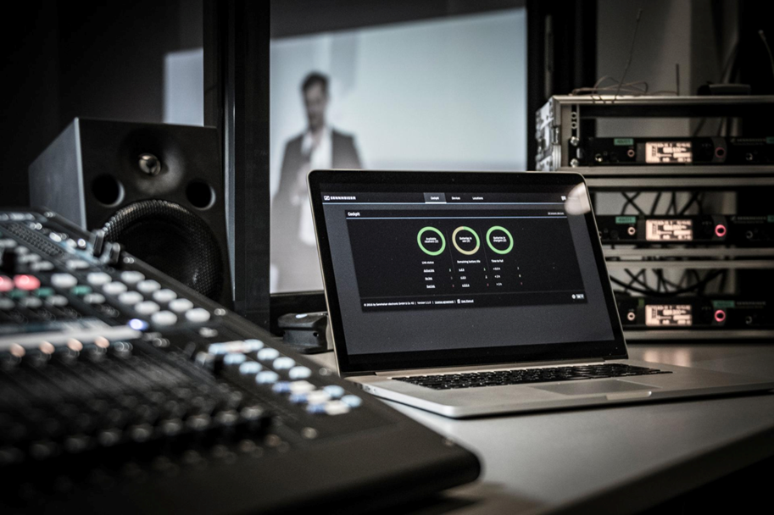 *Sennheiser Control Cockpit is the central software for easy set-up, control and maintenance of the entire SpeechLine Digital Wireless and EW-DX portfolio, and the TeamConnect Family*

The easy-to-use Control Cockpit software provides a global overview of all network-enabled Sennheiser devices. It shows all status information at a glance and makes setting adjustments for one or multiple devices at the same time very easy. The locations overview connects the locations of all components to their respective status information, so the user always knows the location and status of a specific device. The software is accessible everywhere in the intranet via a web browser across all platforms. As a result, the software allows users to manage even huge setups with hundreds of devices with minimal effort.

“We are incredibly excited to have Control Cockpit recognized as the Platinum winner Best Design/Services Tools,” said Peter Grünert, Product Manager Software, Business Communication at Sennheiser. “Managing communication systems can become very complex and require elaborate systems to tackle large deployments of multiple sources. Control Cockpit simplifies the process, allowing users the ability to design and configure systems via an intuitive web GUI. It enables access to real time monitoring and control of all connected Sennheiser components, making system management a breeze — even across an entire campus. This recognition serves as a further validation of Sennheiser’s dedication to creating superior audio systems.”

For more information about Sennheiser and its solutions, visit [www.sennheiser.com](http://www.sennheiser.com/).

###

**About the Sennheiser brand**

We live and breathe audio. We are driven by the passion to create audio solutions that make a difference. Building the future of audio and bringing remarkable sound experiences to our customers – this is what the Sennheiser brand has represented for more than 75 years. While professional audio solutions such as microphones, meeting solutions, streaming technologies and monitoring systems are part of the business of Sennheiser electronic GmbH & Co. KG, the business with consumer devices such as headphones, soundbars and speech-enhanced hearables is operated by Sonova Holding AG under the license of Sennheiser.

[www.sennheiser.com](http://www.sennheiser.com)

[www.sennheiser-hearing.com](http://www.sennheiser-hearing.com)

**Global Press Contact**

Jeff Horan

[jeffrey.horan@sennheiser.com](mailto:jeffrey.horan@sennheiser.com)

+1 860-598-7539